Name: Christian Alvarez
Date: November 16, 2025
Class: IT2249
Unit: U6A1 Console Register For Course

Source Code
1. 1. package u6a1_consoleregisterforcourse;
2. 2.
3. 3. import java.util.Scanner;
4. 4.
5. 5. /**
6. 6. *
7. 7. * @author omora
8. 8. */
9. 9. public class U6A1_ConsoleRegisterForCourse {
10. 10.
11. 11. public static void main(String[] args) {
12. 12.
13. 13. Scanner scn = new Scanner(System.in);
14. 14.
15. 15. //choice is the current menu selection
16. 16. //firstChoice is the first menu selection mande by the user
17. 17. //secondChoice is the second menu selection mande by the user
18. 18. //thirdChoice is the third menu selection mande by the user
19. 19. // a choice of 0 means the choice has not been made yet
20. 20. int choice;
21. 21. int firstChoice = 0, secondChoice = 0, thirdChoice = 0;
22. 22. int totalCredit = 0;
23. 23. String yesOrNo;
24. 24.
25. 25. do {
26. 26.
27. 27. choice = getChoice(scn);
28. 28.
29. 29. switch (ValidateChoice(choice, firstChoice, secondChoice, thirdChoice, totalCredit)) {
30. 30. case -1:
31. 31. System.out.println("**Invalid** - Your selection of " + choice + " is not a recognized course.");
32. 32. break;
33. 33. case -2:
34. 34. System.out.println("**Invalid** - You have already registerd for this " + ChoiceToCourse(choice) + " course.");
35. 35. break;
36. 36. case -3:
37. 37. System.out.println("**Invalid** - You can not register for more than 9 credit hours.");
38. 38. break;
39. 39. case 0:
40. 40. System.out.println("Registration Confirmed for course " + ChoiceToCourse(choice) );
41. 41. totalCredit += 3;
42. 42. if (firstChoice == 0)
43. 43. firstChoice = choice;
44. 44. else if (secondChoice == 0)
45. 45. secondChoice = choice;
46. 46. else if (thirdChoice == 0)
47. 47. thirdChoice = choice;
48. 48. break;
49. 49. }
50. 50.
51. 51. WriteCurrentRegistration(firstChoice, secondChoice, thirdChoice);
52. 52.
53. 53. System.out.print("\nDo you want to try again? (Y|N)? : ");
54. 54.
55. 55. yesOrNo = scn.nextLine().toUpperCase();
56. 56.
57. 57. } while (yesOrNo.equals("Y"));
58. 58.
59. 59. System.out.println("Thank you for registering with us");
60. 60.
61. 61. }
62. 62.
63. 63.
64. 64. public static int getChoice(Scanner scn) {
65. 65. System.out.println("Please type the number inside the [] to register for a course");
66. 66. System.out.println("[1]IT4782\n[2]IT4784\n[3]IT4786\n[4]IT4789\n[5]IT2230\n[6]IT3345\n[7]IT3349");
67. 67. System.out.print("Enter your choice : ");
68. 68. String input = scn.nextLine().trim();
69. 69.
70. 70. // Check if input is empty or not a number
71. 71. if (input.isEmpty()) {
72. 72. return -1;
73. 73. }
74. 74.
75. 75. try {
76. 76. return Integer.parseInt(input);
77. 77. } catch (NumberFormatException e) {
78. 78. return -1;
79. 79.
80. 80.
81. 81. }
82. 82. }
83. 83.
84. 84. //This method validates the user menu selection
85. 85. //against the given registration business rules
86. 86. //it returns the following code based on the validation result
87. 87. // -1 = invalid, unrecognized menu selection
88. 88. // -2 = invalid, alredy registered for the course
89. 89. // -3 = invalid, No more than 9 credit hours allowed
90. 90. // 0 = menu selection is valid
91. 91. public static int ValidateChoice(int choice, int firstChoice, int secondChoice, int thirdChoice, int totalCredit) {
92. 92.
93. 93. // Validate user menu selection (the int choice method arguement)
94. 94. // against the given registration business rules
95. 95. // Check if the choice is a valid menu option (1-7)
96. 96. if (choice < 1 || choice > 7) {
97. 97. return -1; // Invalid, unrecognized menu selection
98. 98. }
99. 99.
100. 100. // Check if the user has already registered for this course
101. 101. if (choice == firstChoice || choice == secondChoice || choice == thirdChoice) {
102. 102. return -2; // Invalid, already registered for the course
103. 103. }
104. 104.
105. 105. // Check if adding another course would exceed 9 credit hours
106. 106. // Each course is 3 credits, so totalCredit + 3 must not exceed 9
107. 107. if (totalCredit + 3 > 9) {
108. 108. return -3; // Invalid, no more than 9 credit hours allowed
109. 109. }
110. 110.
111. 111. return 0;
112. 112. }
113. 113.
114. 114. public static void WriteCurrentRegistration(int firstChoice, int secondChoice, int thirdChoice) {
115. 115.
116. 116. if (firstChoice == 0)
117. 117. System.out.println("Current course registration: { none } " );
118. 118. else if (secondChoice == 0)
119. 119. System.out.println("Current course registration: { " + ChoiceToCourse(firstChoice) + " }" );
120. 120. else if (thirdChoice == 0)
121. 121. System.out.println("Current course registration: { " + ChoiceToCourse(firstChoice) +
122. 122. ", " + ChoiceToCourse(secondChoice) + " }");
123. 123. else
124. 124. System.out.println("Current course registration: { " + ChoiceToCourse(firstChoice) +
125. 125. ", " + ChoiceToCourse(secondChoice) + ", " + ChoiceToCourse(thirdChoice) + " }");
126. 126. }
127. 127.
128. 128. public static String ChoiceToCourse(int choice) {
129. 129. String course = "";
130. 130. switch (choice)
131. 131. {
132. 132. case 1:
133. 133. course = "IT4782";
134. 134. break;
135. 135. case 2:
136. 136. course = "IT4784";
137. 137. break;
138. 138. case 3:
139. 139. course = "IT4786";
140. 140. break;
141. 141. case 4:
142. 142. course = "IT4789";
143. 143. break;
144. 144. case 5:
145. 145. course = "IT2230";
146. 146. break;
147. 147. case 6:
148. 148. course = "IT3345";
149. 149. break;
150. 150. case 7:
151. 151. course = "IT3349";
152. 152. break;
153. 153. default:
154. 154. break;
155. 155. }
156. 156. return course;
157. 157. }
158. 158.
159. 159. }
160. 160.
161.

Screenshots
Failing Test
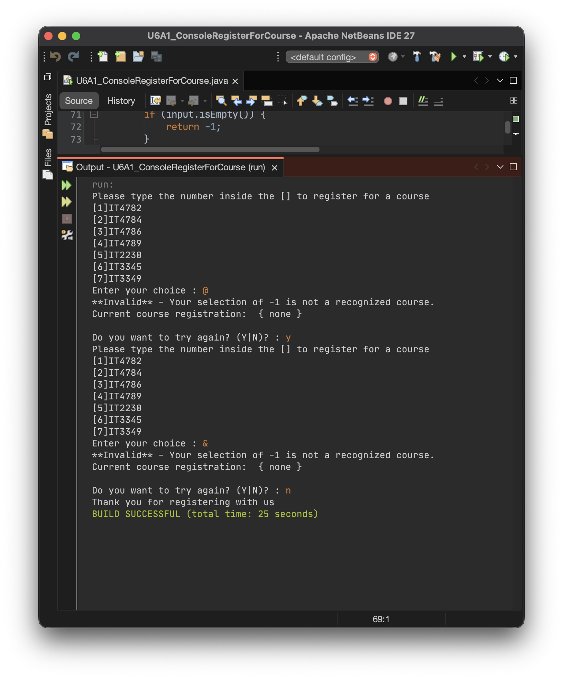

Passing Test
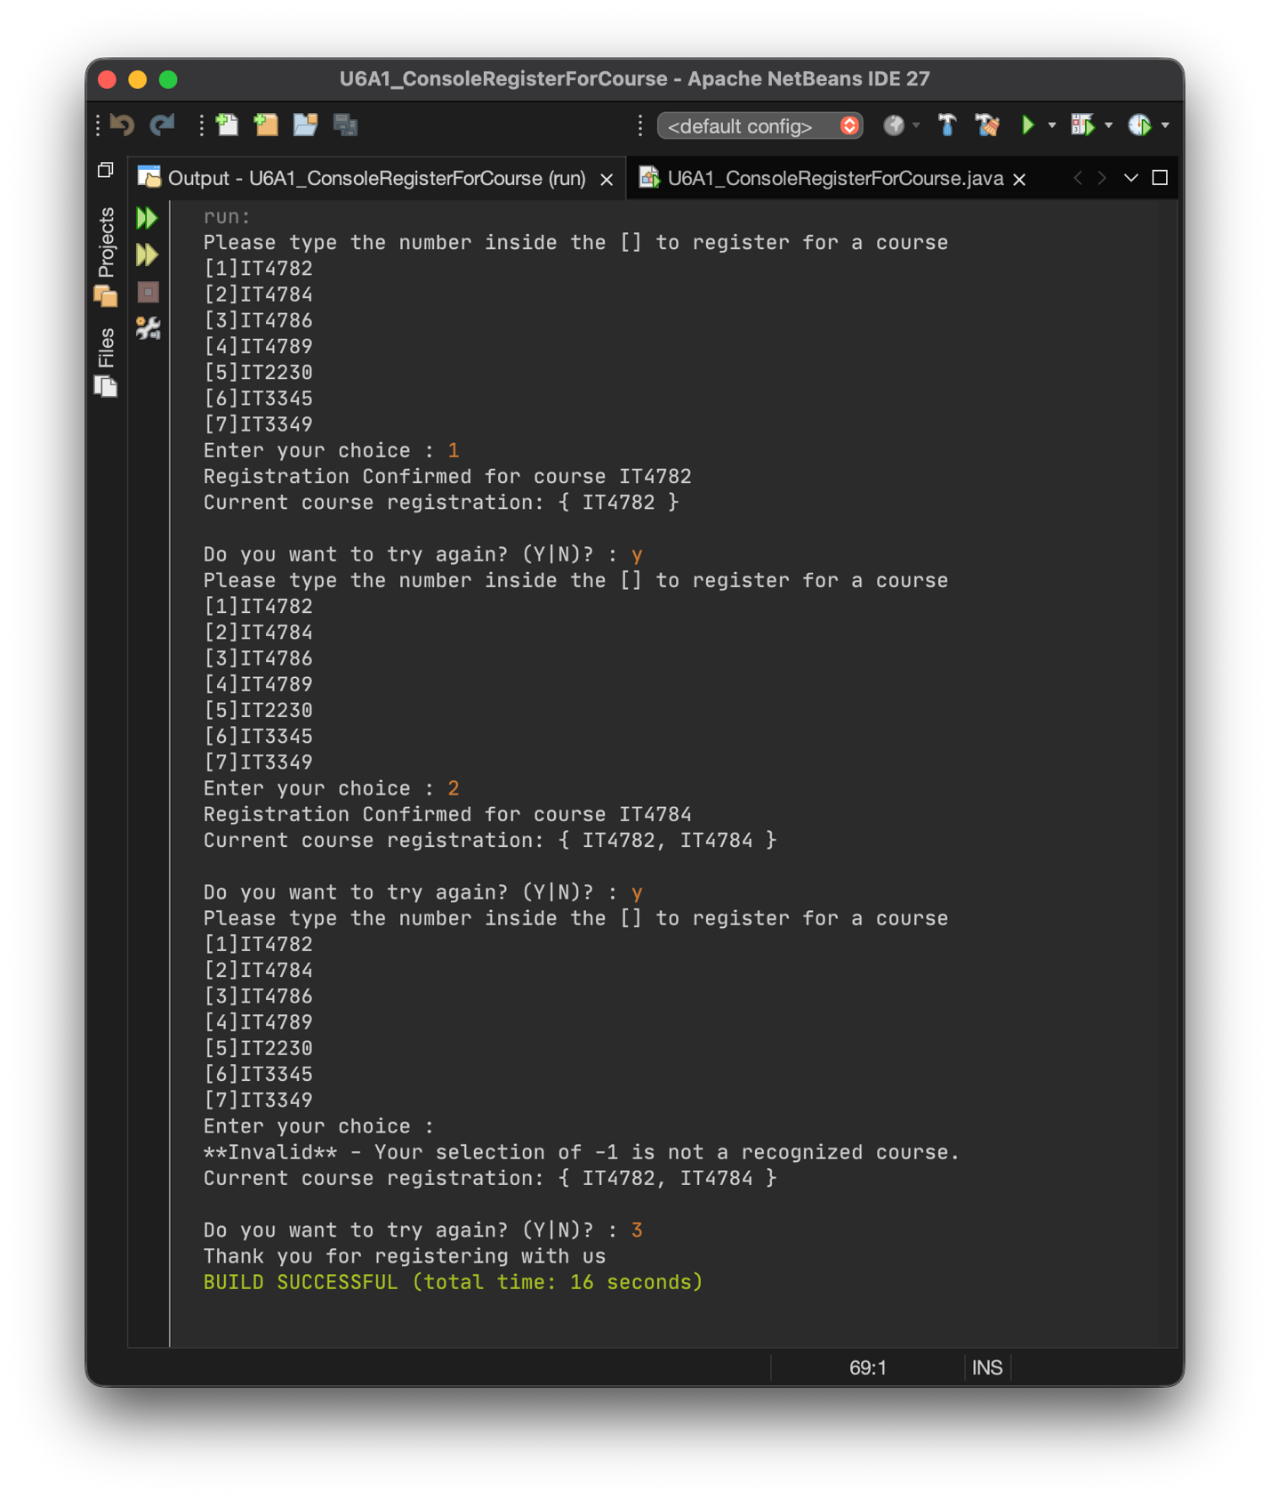

Explanation
This assignment involved completing a Java console application for student course registration by implementing the missing input validation and business logic. The original code provided a framework with several methods already in place, but the core validation components needed to be developed to meet the specified requirements.
I enhanced the getChoice method to handle invalid input through exception handling and checking for empty strings, which prevents the program from crashing when users enter non-numeric values or just press enter. The ValidateChoice method required implementing three specific validation rules: ensuring choices fall within the valid range of 1 to 7, preventing duplicate course registrations, and verifying that the 9 credit hour limit would not be exceeded. Each rule returns a distinct error code when violated, allowing the main method to display appropriate error messages to the user.
Testing confirmed the program works correctly across different scenarios. Invalid inputs like "0" and "8" were properly rejected with clear error messages. Valid registrations for IT4782 and IT4784 processed successfully, with the program accurately tracking multiple enrollments and updating the display after each selection. Edge cases like blank input were handled without causing any crashes or unexpected behavior.
This project reinforced several important programming concepts including modular method design, systematic validation checking, and exception handling with try-catch blocks. The experience improved my understanding of defensive programming practices and demonstrated why separating validation logic from display logic creates better code organization and reusability. Working through the different validation scenarios also highlighted the importance of testing thoroughly to ensure all business rules function as intended.

